GOVERNMENT POLYTECHNIC CHANNASANDRA

DEPARTMENT OF COLLEGIATE AND TECHNICAL EDUCATION

GOVERNMENT POLYTECHNIC CHANNASANDRA

KADUGODI POST, BANGALORE – 560067

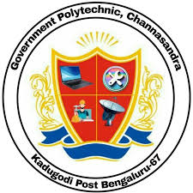

INTERNSHIP SYNOPSIS

ON

(ORACLE CORPORATION)

In partial fulfillment for the award of degree of

Diploma in Computer Science & Engineering

Submitted by

Reshma (183CS22033)

5th Semester

Under the Guidance of

Smt. Sunitha A N

Department of Computer Science & Engineering

Government Polytechnic Channasandra